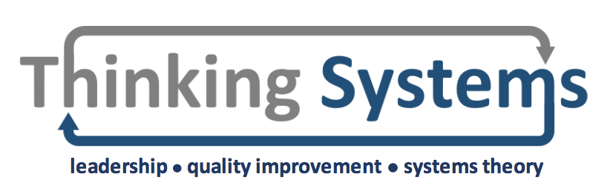

Haringey and Islington CCG Leadership Training Day
Further Reading

Brown, J. and Issacs, D. The World Café: Shaping our futures through conversations that matter. San Francisco: Berret Koehler

Goodman, M. (1997) Systems thinking: what, why, when, where and how. The Systems Thinker. 8(2): pp 6 – 7.

Gordon, P. Plamping, D. and Pratt, J. (2010) Working in systems: the landscapes framework. Centre for Innovation in Health Management. Available from: www.wholesystems.co.uk/landscapes.pdf [Accessed on 01 May 2019]

Grint, K. (2008) Wicked problems and clumsy solutions: the role of leadership. Clinical Leader. 1(2)

King’s Fund (2011) The future of leadership and management in the NHS: no more heroes. Available from: www.kingsfund.org.uk/sites/default/files/future-of-leadership-and-management-nhs-may-2011-kings-fund.pdf [Accessed 15/07/2019]

Malby, B. and Anderson-Wallace, M. (2016) Networks in healthcare: managing complex relationships. Croydon: Emerald Group Publishing Limited

Malby, B. and Fischer, M. (2006) Tools for Change: an invitation to dance. Chichester: Kingsham Press

Malby, R. and Edmonstone, J. (2014) Effective medical leadership for a complex NHS. British Journal of Hospital Medicine. 74(8): pp 461 – 463

Pearce, W. (2007) Making social worlds: a communication perspective. Oxford: Blackwell Publishing.

Pratt, J. Gordon, P and Plamping, D. (1999) Working whole systems: putting theory into practice. London: King’s Fund Publishing

Rubbra, T (2016) On purpose. Available from: https://vanguard-method.net/2016/08/on-purpose/ [Accessed 02/07/2019]

Seddon, J. (2008) Systems thinking in the public sector: the failure of the reform regime and a manifesto for a better way. Axminster: Triarchy Press

Sweeny, B. and Meadows, D. (1995) The Systems Thinking Playbook. Vermont: Chelsea Green Publishing

Vogt, E. Brown, J. and Isaacs, D. (2003) The art of powerful questions: catalysing, insight, innovation, and action. Mill Valley: Pegasus Communications

Wheatley, M. (1999) Leadership and the new science: discovering order in a chaotic world. Oakland: Berrett-Koehler Publishers

